Knowledge Article. Installing The Zscaler root certificate on Android devices
This article provides step-by-step instructions for manually installing the Zscaler Trusted Root Certification Authority (CA) certificate on an individual Android device.

Steps:
- of 5: Download the SSL certificate file from the NT website referenced in the communication from the IT team and save it directly to the Downloads folder on your phone. https://www.northerntrust.com/remoteaceess/

- of 5: Navigate to Settings and select Security and Privacy

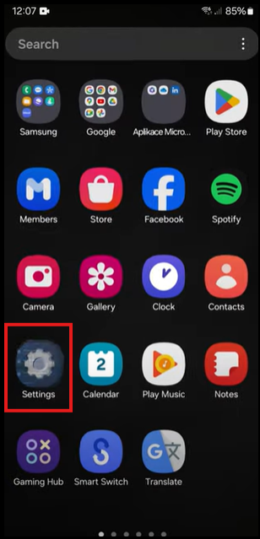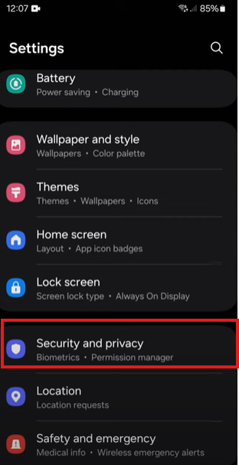

- of 5: Scroll down to and select More Security Settings
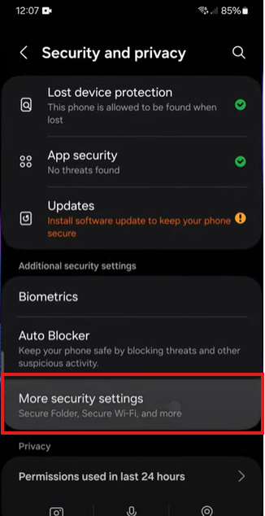

- of 5: Scroll down to Credential Storage, select Install from device storage.
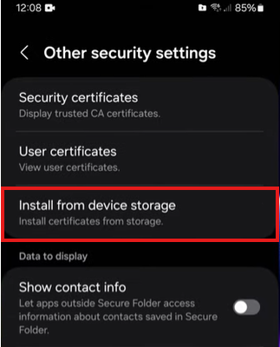

- of 5: Select CA Certificate and click on Install Anyway.
The Zscaler Root certificate should be in the Downloads folder. Select Done.
The certificate will be installed.

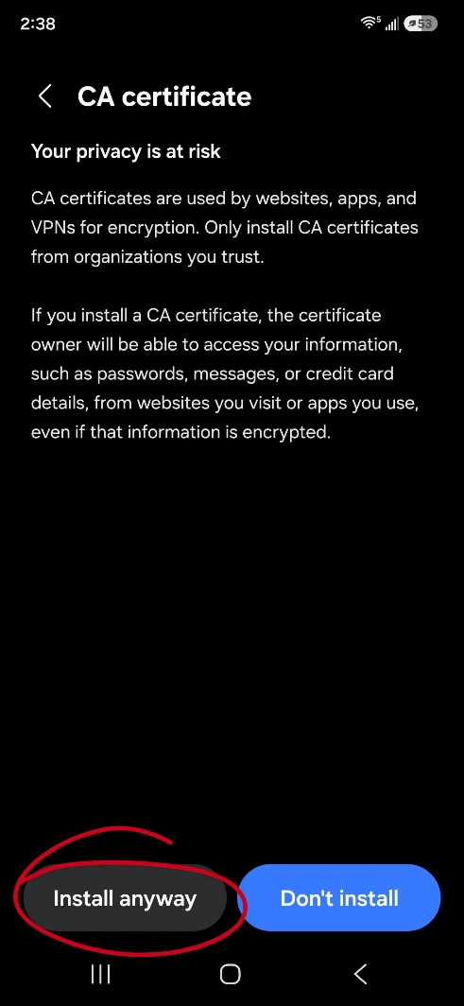

Notes:
For Google Pixel / Motorola / Others
- Open your device's Settings app.
- Tap Security & privacy, then More security settings.
- Tap Encryption & credentials, then Install a certificate.
- Choose CA certificate.
- Read the warning, then tap Install anyway.
- Use the file browser to locate your downloaded certificate file in your Downloads folder and select it

Support: | network_security_operations@ntrs.com |  | Owner: | al318
SME: | vb216, man6, rjk4 |  | Issue Source: | Self-Identified
Scope: | Personal mobile devices running on Android OS |  | Impact: | Moderate

