Knowledge Article. Installing The Zscaler root certificate on Apple OS mobile devices

Steps:
- Using the Safari Browser, go to the website: https://www.northerntrust.com/remoteaceess/

- Click on the “Download Zscaler Root Certificate” link.

- Browser will ask if you want to allow the download of the configuration profile, click “Allow”

  - 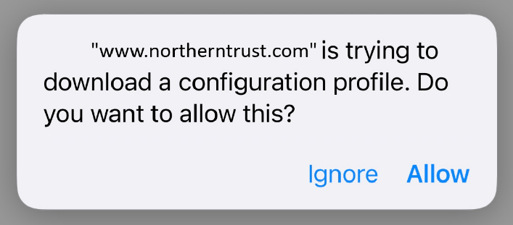

- A prompt will display the Profile has been downloaded. Click “Close”

  - 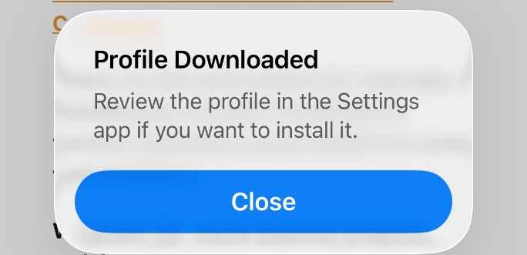

- On the iPhone/iPad go to Settings. Click on “Profile Downloaded”
  - 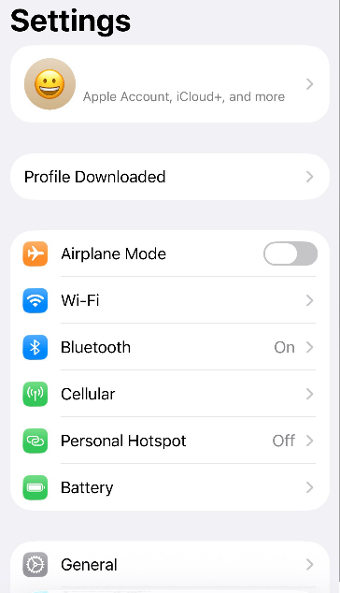

- Under Install Profile click “Install”
  - 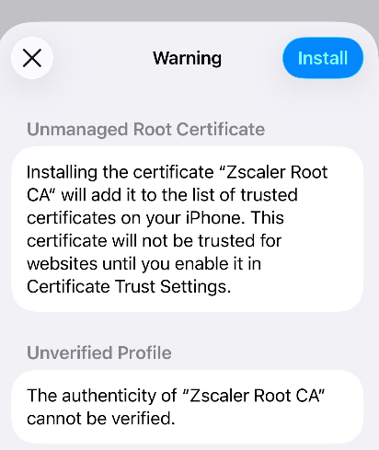

- Enter your mobile device password when prompted.

- Under the Warning click “Install”
  - 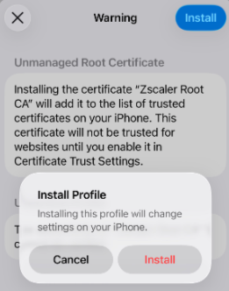

- Go back to Settings, then go to About and then Certificate Trust Settings.
  - Under Enable Full Trust for Root Certificate, enable the Zscaler root certificate
  - At the Warning prompt click “Continue”
  - 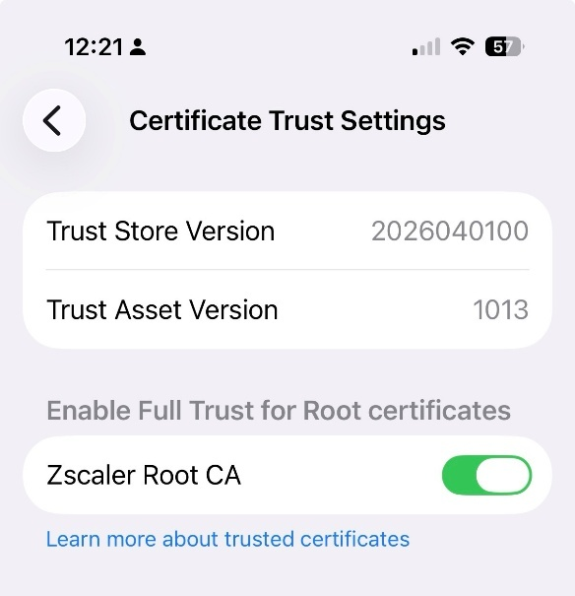

- Installation is complete

